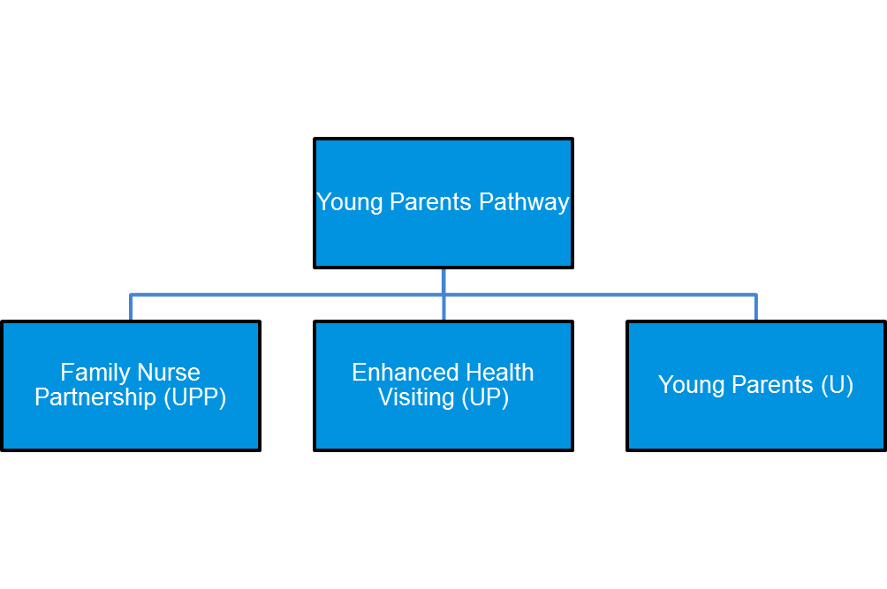
Cambridgeshire and Peterborough
Healthy Child Programme

Young Parents’ Pathway and Family Nurse Partnership
REFERRAL FORM

First time young parents, 19 years and under, not meeting the FNP criteria. In agreement with the young parent, the Health Visitor at the antenatal contact will offer additional visits by a Young Parent Nursery Nurse.

This means up to 4 visits in pregnancy and up to 5 visits during the baby’s first year. In some cases these can be extended to further 4 visits up to child’s 2nd birthday.

Referrals not required - theses will be arranged in conjunction with mandated Health Visitor antenatal contact.
First time parents under 19 years with complex needs. FNP programme is an in-depth, structured, home visiting programme from early in pregnancy, up to baby’s first birthday and may extend to child’s 2nd birthday. It is offered in agreement with the young person and replaces the Health Visiting service.

Please complete referral form below
and send to:

Cambs & P’boro Family Nurse Partnership
Oak Tree Centre
Oak Drive
Huntingdon PE29 7HN

Telephone:
01480 425385

Email:
ccs.fnpcambsandpboro@nhs.net

Young parents with universal needs offered universal pathway, starting with the offer of an antenatal contact with the Health Visitor.

To find out more about the young parents pathway, please use this link to watch our video: https://bit.ly/cambspboroypp

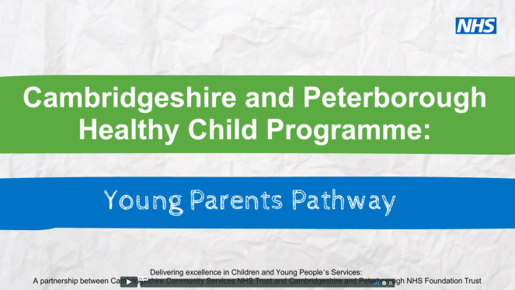

QUALIFYING CRITERIA:
19 Years and Under at Time of Conception
and Pregnant with their First Baby

Family Nurse Partnership should be recommended to the Young Person should they or their Partner (if relevant) meet 4 or more of the below markers
Clients with less than 4 markers but with significant vulnerabilities should also be considered
Please remember that all cases incorporate an element of professional judgement. If you think that there are external circumstances outside of this criteria that you believe makes a young person vulnerable please expand in the comment box
Additional Details

Date Form Received:

………………………………………

Does the Young Person have a Communication/
information support need?
Y o N o

If yes please provide details
……………………………………………………
What is their preferred method of contact?
……………………………………………………………………………

Other Issues
O Unstable living arrangements
O Living unsupported away from home (under 18) or has done previously for a period of 3 months or more
O Negative Parenting experiences and/or attachment issues
O 16 years old or under

Risk Taking Behaviours
O Perpetrator of crime/anti-social or violent behaviour

Safeguarding
O Current signs of Abuse/Domestic Abuse or Family Violence
O Victim of Child Sexual Exploitation and/or FGM

O I confirm that I have informed the client of the purpose of this information and clearly explained that necessary data may be passed on to other health or social support services if deemed in the best interest of the client and that client has the capacity to understand and has consented to submitting this information. Client name, DOB, contact details and notifying professional will be sent to youth services and Children’s Centres who may contact the young person to offer optional additional support

Social Care
O Previously in Care
O Currently in Care
O Recent Care Leaver
O Current Social Care
O History of Children’s
Social Care
Involvement (CP/CIN)

Health Needs
O Emotional Well Being/Mental Health Issues
O Smoker who doesn’t plan to give up during pregnancy
O Substance Misuse
O Concealed Pregnancy
O Concerns regarding Self -Management of Health needs
O Limited Self-Efficacy

All completed forms should be returned to the relevant FNP Team

Contact details are found on the back of this form
Form completed by:
Name:
Email:
Job Role:
Telephone:

Client Details:
Name:
Date of Birth:
Address:
Estimated Due Date:
GP
NHS Number:
Contact Number:

