Children and Young People’s Services

Statutory Assessment and Resources Team
SCO2209
Scott House
5 George Street
Huntingdon
PE29 3AD

04.09.2023
To, Head teacher/SENCO

If your setting has a child with moving and handling needs due to physical disability, you will need to ensure that the staff supporting the child have appropriate training.

- All supporting staff require a yearly mandatory update.
- All supporting staff to complete a Health Questionnaire prior to receiving training. School to keep this Questionnaire as part of school’s health and safety records.
- All supporting staff must complete Part 1 e-learning prior to Part 2 training. Staff may be turned away from face to face training if Part 1 has not been completed.

There is a training package for Teaching Assistant Staff new to role and refresher training.

This will improve staff's everyday awareness and increase their understanding of each task they are/will be doing in the specific environment and how it may affect their health and safety

Following completion of the training staff will be emailed a feedback form for completion and return, to enable continued improvements to be made to meet the needs of the children and staff.

For a child who is transitioning to a new school, historically it has proven to be extremely useful for nursery/primary school staff (for child transitioning into secondary school) to be available to go through the child specific techniques that they have been using.

For utmost effectiveness, schools to identify their more experienced staff and double them up with new staff to share the learning.

Please see our Website for more general information;

https://www.cambscommunityservices.nhs.uk/cambridgeshire-children's-occupational-therapy/about-us/back-care-training-fo-professionals

We look forward to working with you and will strive to provide the best support that we are able to under the current pandemic guidelines.

PLEASE NOTE ALL FACE TO FACE TRAINING IS BOOKABLE VIA EVENTBRITE

Moving and Handling Advisors
Cambridgeshire Community Services

(i) Training package for Teaching Assistant Staff

- E-learning:

- Staff to book onto face-to-face training via Eventbrite (see links in this letter)
Once booked, staff member to email ​CCS-TR.CambsMovingandHandling@nhs.net to register for e-learning.
E-LEARNING MUST BE COMPLETED BEFORE ATTENDING FACE TO FACE TRAINING
- CCS Moving and Handling Adviser will email log-in details and attach Health Questionnaire.

- Staff to complete Health Questionnaire. School to ensure this is kept in school as part of health and safety records.

- Staff will need to have approximately 60 minutes allocated to them for completion of the training.

- Pass mark of 80% has been set.

- Staff to send email to ​CCS-TR.CambsMovingandHandling@nhs.net to advise completion.

- If the 80% pass mark has not been achieved staff will be asked to retake the training

- Face to Face session with Trainer

- To access face to face training, ALL participants MUST complete the e-learning training.

- Face to face sessions are limited to 6 participants per session (see website for dates) https://www.cambscommunityservices.nhs.uk/cambridgeshire-children's-occupational-therapy/about-us/back-care-training-fo-professionals)

If you require outside of these timings, please email CCS-TR.CambsMovingandHandling@nhs.net

- Duration: Two hours
- Location: Noted on the Eventbrite booking

Areas covered include
- Specific questions from staff following the e-learning
- Work place problem solving
- Risk assessment and education on TILEE (Task, Individual, Load, Environment and Equipment).
  - Bringing a client forward in their chair
  - Sit to Stand
  - Mo-lift Raiser
  - Sara Steady
  - Hoisting a client

TO BOOK YOUR PLACE PLEASE CLICK ON THE RELEVANT LINK BELOW

FACE TO FACE TRAINING DATES - Sepember 2023 – November 2024

(I) Training package NEW TO ROLE 0930-1130

(ii) Training package for Teaching Assistant Staff – REFRESHER 1230-1430

Date | New starter | Refresher
20th September 2023 | https://www.eventbrite.co.uk/e/421254452407 | https://www.eventbrite.co.uk/e/421254953907
13th October 2023 | https://www.eventbrite.co.uk/e/421256307957 | https://www.eventbrite.co.uk/e/421256949877
22nd November 2023 | https://www.eventbrite.co.uk/e/421257802427 | https://www.eventbrite.co.uk/e/421259858577
26th January 2024 | https://www.eventbrite.co.uk/e/635372585507 | https://www.eventbrite.co.uk/e/635374661717
28th February 2024 | https://www.eventbrite.co.uk/e/635380559357 | https://www.eventbrite.co.uk/e/635381381817
22nd March 2024 | https://www.eventbrite.co.uk/e/635386677657 | https://www.eventbrite.co.uk/e/635387339637
24th April 2024 | https://www.eventbrite.co.uk/e/635387660597 | https://www.eventbrite.co.uk/e/635388001617
24th May 2024 | https://www.eventbrite.co.uk/e/635388352667 | https://www.eventbrite.co.uk/e/635388663597
26th June 2024 | https://www.eventbrite.co.uk/e/635390308517 | https://www.eventbrite.co.uk/e/635390840107
19th July 2024 | https://www.eventbrite.co.uk/e/635392083827 | https://www.eventbrite.co.uk/e/635392805987
11th September 2024 | https://www.eventbrite.co.uk/e/635393718717 | https://www.eventbrite.co.uk/e/635395022617
18th October 2024 | https://www.eventbrite.co.uk/e/635395524117 | https://www.eventbrite.co.uk/e/635395845077
20th November 2024 | https://www.eventbrite.co.uk/e/635396587297 | https://www.eventbrite.co.uk/e/635397078767

EDGE training, who provide the necessary training to Cambridgeshire County Council Manual Handling Advisors support the delivery of this training package.

.

APPENDIX

Moving and Handling E-Learning Guidance

1. Use this link to get onto the website: https://edgeservices.co.uk/
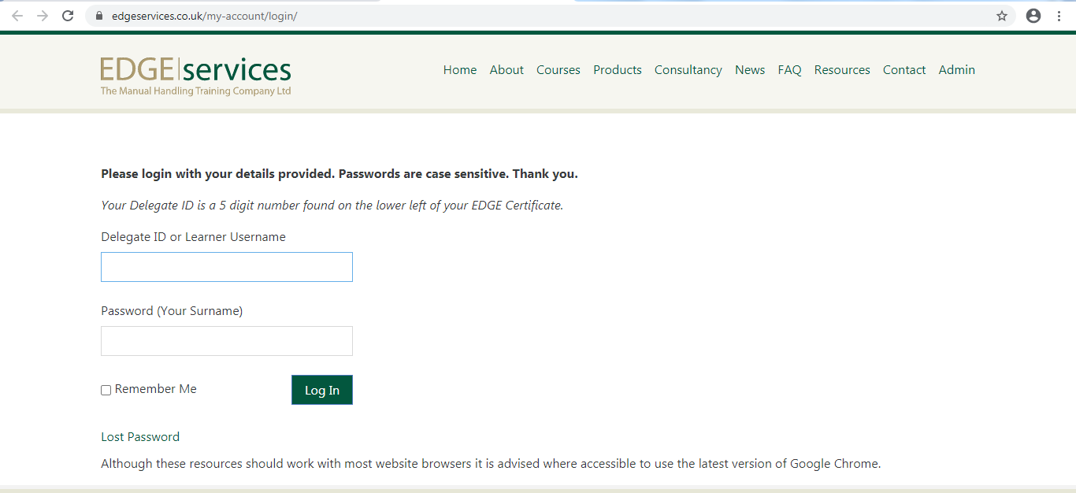
2. You will then need to select ‘Resources’

3. When you email CCS-TR.CambsMovingandHandling@nhs.net to register, you will be sent your Learner ID. Your password is your surname. Please then click ‘Log In’
4. You then need to ‘View Course’

PART 1: e-learning

Please note this will take around 60 minutes. It has videos, text to read and then 18 questions to be answered.

Once completed, please email CCS-TR.CambsMovingandHandling@nhs.net

- If the 80% pass mark has not been achieved you will be asked to retake the training
- Any queries from the e-learning can be answered during Part 3 of the training.

If you have further questions or need further advice please contact the Moving and Handling Team on: CCS-TR.CambsMovingandHandling@nhs.net

