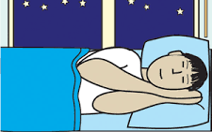

I need to have a sleep study done.

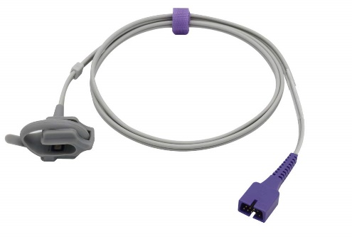

When it is time to go to sleep, the monitor will need to be attached to my finger or toe using a special wire called a PROBE.
I NEED A SLEEP STUDY

This is because the doctor wants to see how well I breathe when I am asleep.

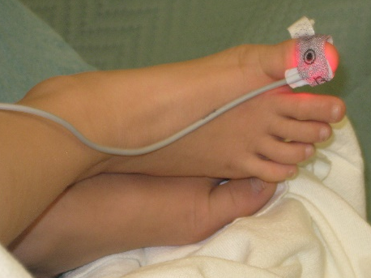

The probe has a red light which shines on me and sends numbers to the machine. I will not be able to feel the light and it cannot hurt me. It uses a sticky plaster to stay on.

I will be given a special machine to use at home, called a SLEEP STUDY MONITOR.

The machine needs to stay attached for at least 7 hours overnight to give the doctor enough information to look at.

The machine might make some beeping noises but the volume can normally be turned down so it doesn’t beep too much and wake me up.

The doctor will get the results from the sleep study and be able to see what happens to my breathing when I am asleep.

I must not take the probe off without telling an adult, or the sleep study might not get enough information for the doctor.

I will feel proud of myself for doing the sleep study.

When I have finished the sleep study, the machine will be turned off and taken back to the nurses who will send the results to the doctor.

