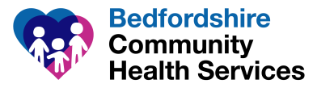
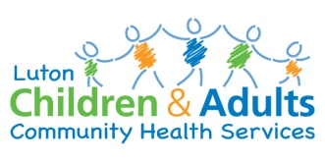
Launch of Bedfordshire and Luton Children’s Health Hub – updated August 2022
What is the Health HUB?
- The Bedfordshire and Luton Children’s Health HUB has been created to make contacting our services by telephone and email easier and more convenient.
- There will be one shared telephone number, and an email address to access some services.

Which services are included?
The Health HUB will bring together calls and emails for the following teams (as indicated):
- Bedfordshire and Luton 0-19 Teams: Health Visiting and School Nursing (calls and emails)
- Bedfordshire and Luton Children in Care Services (calls only)
- Luton Community Paediatrics Service (calls only)
- Beds Community Paediatrics Service (calls only)
- Beds and Luton Speech and Language Services (calls only)
- EHCP Coordination Services (calls only)
Services that are calls only will continue to use their existing email addresses until further notice.
When does the Health HUB launch?

- The Health HUB went live on Tuesday 1st June 2021
- The telephone number is : 0300 555 0606
- The email address is: ccs.bedsandlutonchildrenshealthhub@nhs.net
- The opening hours are 9-5 Monday to Friday. The Health HUB is closed at weekends and Bank Holidays.

Reasons for contacting the Health HUB
The Health HUB will be the first point of contact for each of the services it covers. Calls will include:
- Enquiries about appointments and support from School Nurses and Health Visitors
- Calls from professional partners such as GP Surgeries and Social Care Teams
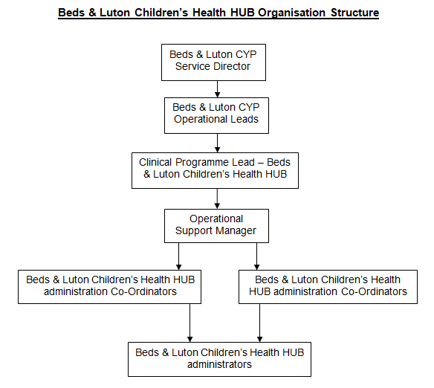
- Help with accessing clinics
Meet the team
- The Clinical Programme Lead for the team is Lorraine Foster
- Team members are based in both Luton (The Poynt) and Bedford (Woburn Court)
- The Team will consist of Health HUB Administrators, Co-ordinators and an Operational Support Manager based across Bedfordshire and Luton
Expanding the Health HUB
- The Health HUB will grow over time to include all CCS Children’s Services across Bedfordshire and Luton
- We will contact you at each stage as services move over to join the Health HUB contact point.

