#FreeToFeedCP Social Media Guide

Thank you for choosing to support the #FreeToFeedCP campaign! Your social media support is essential to ensure that mums can feel confident and supported if they choose to breastfeed and/or pump in public.

Feel free to use our example posts below as a starting point and don't forget to use the hashtag #FreeToFeedCP on social media and tag the NHS and District Council.

Our channels are:

Cambridgeshire and Peterborough Healthy Child Programme:
@CambsPboroCYP on Facebook, Instagram and Twitter

South Cambridgeshire District Council:
@SouthCambs on Facebook, Instagram and Twitter

Template social media messages and assets

- Social Media messages to encourage businesses and venues to sign up
Message 1 | As part of the #WorldBreastfeedingWeek ‘Free To Feed’ campaign has launched in South Cambridgeshire to help those who breastfeed and/or pump feel confident and relaxed when feeding or pumping for their baby in public and is encouraging local businesses and venues to take part and become a breastfeeding friendly location. Find out more here: www.scambs.gov.uk/freetofeedcp #FreeToFeedCP
Message 2 | ‘Free To Feed’ campaign has launched to help normalise breastfeeding and pumping in public. We are looking for local businesses to take part by becoming a breastfeeding friendly location. To find out more: www.scambs.gov.uk/freetofeedcp #FreeToFeedCP
Message 3 | Breastfeeding and pumping can be challenging for families, and doing it in public can create some anxiety. That’s why it is important to support families to feel confident and ‘Free To Feed’ in public. 📣BUSINESSES📣 Sign up to become a breastfeeding friendly location. To find out more: www.scambs.gov.uk/freetofeedcp #FreeToFeedCP

- Social Media messages for signed up businesses and venues to use

Message 1 | 🌟Families are ‘Free To Feed’ and pump here!🌟 We’re proud to support those who breastfeed and be part of the South Cambridgeshire #FreeToFeedCP campaign to help them feel more confident when out and about. Find out more here: www.bit.ly/freetofeedcp
Message 2 | We are proud of families who breastfeed and/or pump here! Breastfeeding is normal, healthy and important, so all families should feel ‘Free To Feed’ in public -  including right here! Find out more: www.bit.ly/freetofeedcp #FreeToFeedCP

- Social media messages for families and general public

Message 1 | As part of the #WorldBreastfeedingWeek the #FreeToFeedCP has launched in South Cambridgeshire to help those who breastfeed and/or pump feel confident and relaxed when feeding and/or pumping for their baby in public. To find out more: www.bit.ly/freetofeedcp
Message 2 | #FreeToFeedCP campaign has launched in South Cambridgeshire to help normalise breastfeeding and/or pumping in public while allowing breastfeeding families feel confident and relaxed when feeding or pumping for their baby in public. Find out more here: www.bit.ly/freetofeedcp
Message 3 | The #FreeToFeedCP campaign is looking for South Cambridgeshire families who breastfeed and/or pump in public to share their thoughts and experiences by taking a short survey to help start a positive change in the community and 👉 COMPLETE YOUR SURVEY: www.bit.ly/freetofeedcp-survey 👈
Message 4 | Breastfeeding has amazing health benefits, but not everyone who wants to breastfeed has the support they need to do so. If you are a family from South Cambridgeshire who is breastfeeding and/or pumping, please take the #FreeToFeedCP survey to start a positive change in the community. 👉 www.bit.ly/freetofeedcp-survey 👈
Message 5 | #SouthCambridgeshire families if you know a local business or a venue who is not yet a ‘#FreeToFeedCP’ location, please encourage them to sign up and pledge to become one, where families breastfeeding their little ones are openly welcomed to visit, especially if they feel like they need a safe space when out and about. Find out more here: www.scambs.gov.uk/freetofeedcp #FreeToFeedCP

- Assets and Visuals

You can download the asset pack directly from: www.bit.ly/freetofeedcp
*please note this pack is safely stored on an NHS website*

Examples…
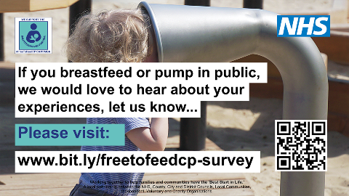
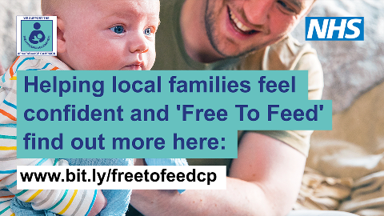
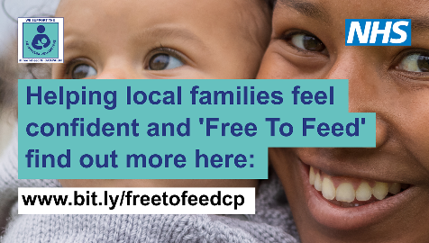
Figure 3 decorative example of social media asset
Figure 2 decorative example of social media asset
Figure 1 decorative example of social media asset

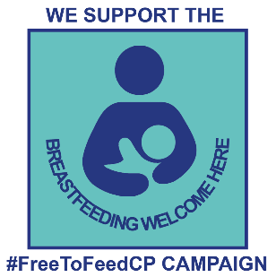
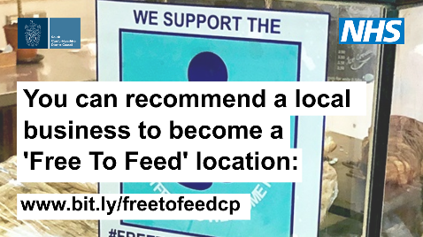
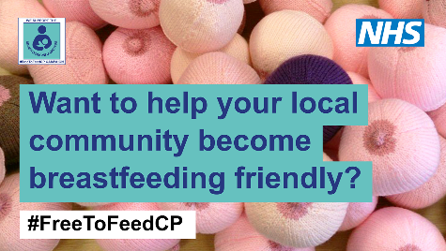
Figure 5 decorative example of social media asset
Figure 4 decorative example of social media asset

