Promotional Pack for Schools
ChatHealth Cambridgeshire and Peterborough
January 2020

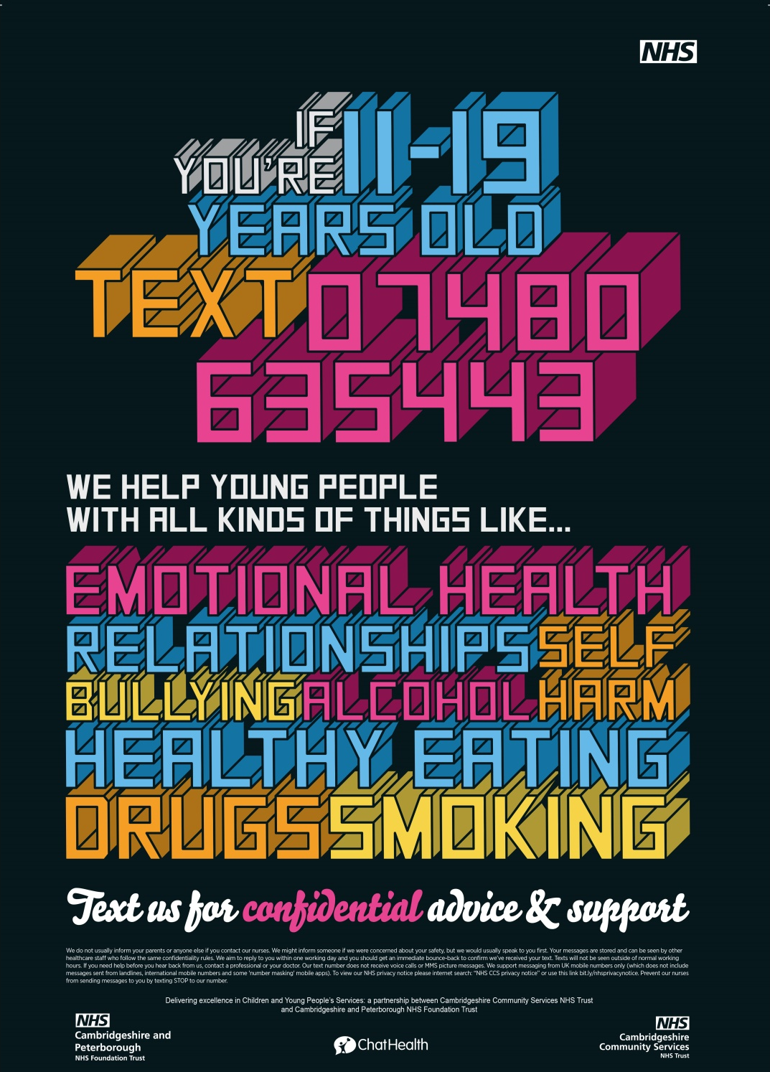

ChatHealth Cambridgeshire and Peterborough Promotional Pack

This promotional pack has been created to help schools promote ChatHealth, a new text messaging service for young people aged 11 – 19 years old in Cambridgeshire and Peterborough.

What is ChatHealth?
ChatHealth is a secure NHS approved text messaging service that is run by our school nursing team in the Cambridgeshire Healthy Child Programme. From 9.30am to 4.00pm Monday to Friday ChatHealth has experienced clinicians online waiting to answer and deal with any messages from young people.

Any messages outside this time frame receive and automated response letting young people know when they will receive a reply or who to contact to get immediate help.

We have created an animation to help explain ChatHealth – please click the picture to view or use this link: https://vimeo.com/354621452

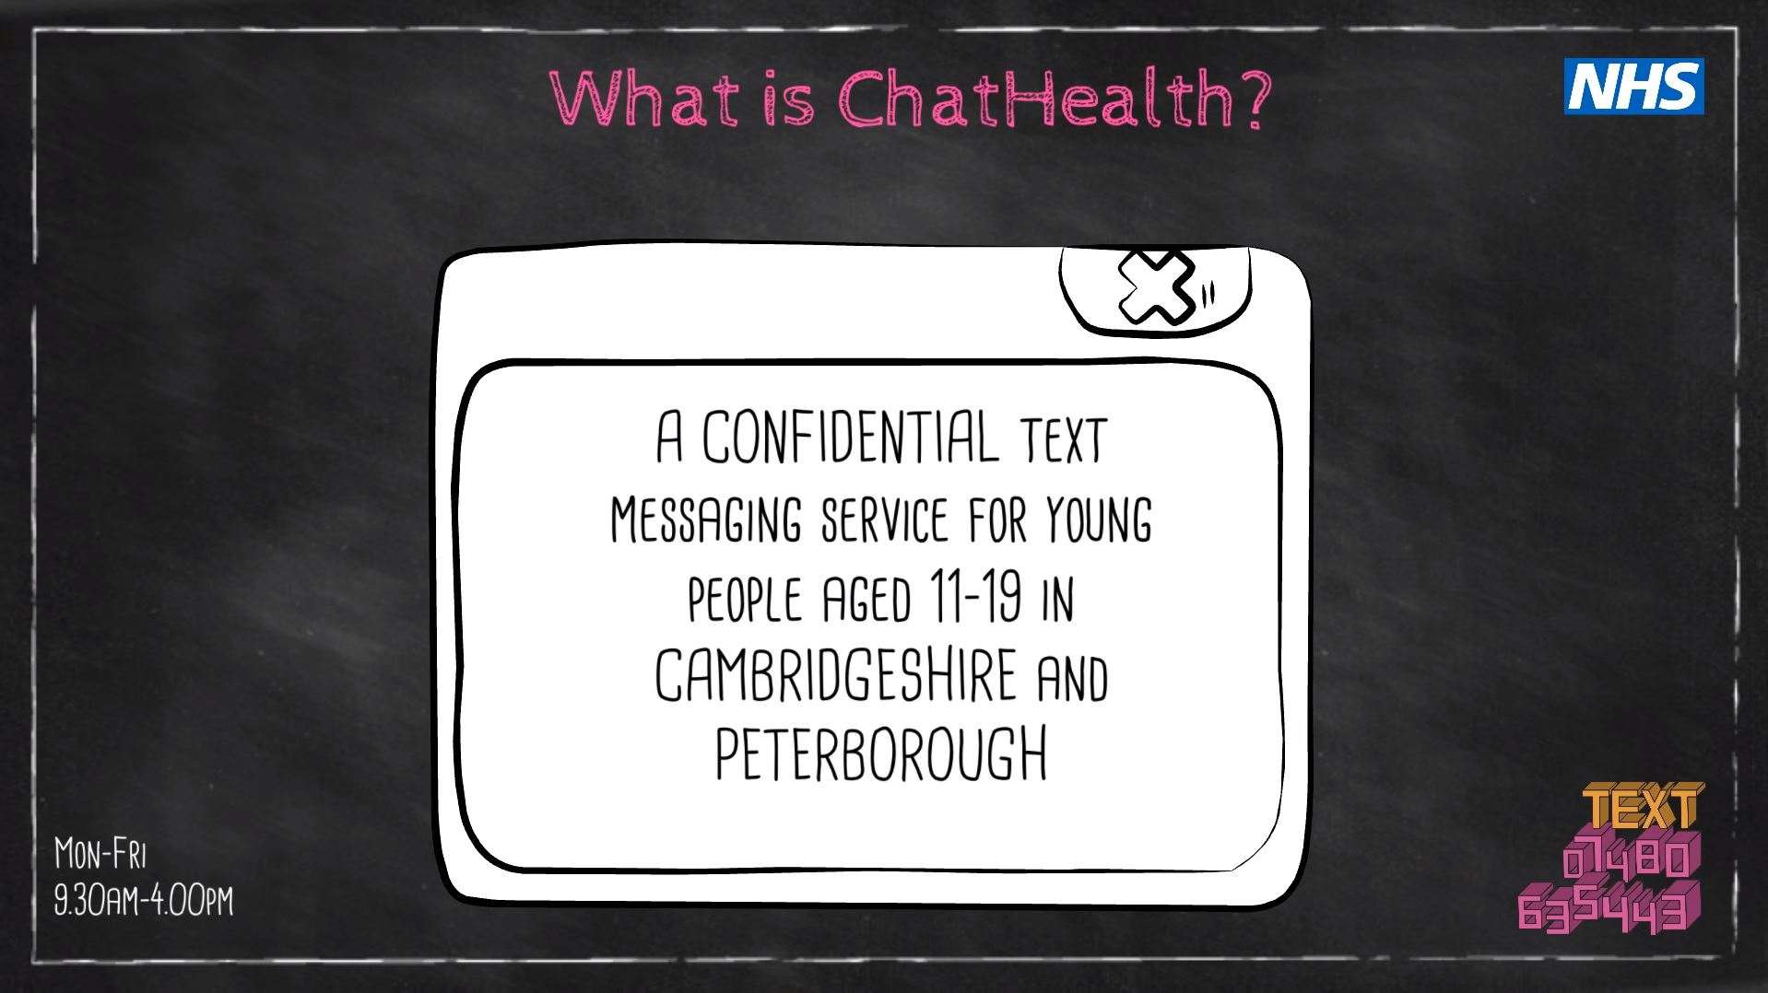

What’s in this pack?

In this pack we have some materials to help your school connect young people with the school nursing service via ChatHealth, scroll down to find out more…

#1 Email Templates

Copy and paste these in an email to send to any of your email groups/distribution lists with young people, parents, families, teachers, or colleagues who work with large groups of young people.

When sending an email to a large database, putting the list of recipients’ email addresses in the BCC field, this will prevent accidental disclosure of personal details to the whole group.

#2 Website Information

Putting our suggested information about ChatHealth on your website along with our animation, this will help your young people, parents and colleagues understand what the service is and hopefully encourage its use.

#3 Newsletter Articles

A selection of long, short and bulletin style templates that you copy and paste into any of your own newsletters.
#4 Resources

How to get more materials to advertise Chathealth

#1 Plain Text Email Template

Introducing…

ChatHealth

ChatHealth is a secure NHS approved text messaging service that is run by the Cambridgeshire Healthy Child Programme.

From 9.30am to 4.00pm Monday to Friday ChatHealth has experienced clinicians online waiting to answer and deal with any messages from young people.

The new platform provides an alternative way for young people to engage with school nurses on topics including relationship advice, healthy eating, smoking cessation, bullying and exam stress.

All users need to do is text 07480 635 443 to start a conversation.

Over the next few months, you may begin to see the distinctly branded ChatHealth credit cards, wristbands, posters around the school community and there is even an animation explaining to service.

CLICK HERE TO WATCH NOW

Please share this email to help us spread the word about ChatHealth!

If you would like to know more about ChatHealth or have any questions, please contact the the Cambridgeshire and Peterborough Healthy Child Programme on: 0300 029 50 50 or send an email to ccs.cpft.hcp@nhs.net

*Please feel free to attach one of the pictures from this document*

#1 HTML Email Template – optimized to function on phones

Introducing…

ChatHealth

ChatHealth is a secure NHS approved text messaging service that is run by the Cambridgeshire Healthy Child Programme.

From 9.30am to 4.00pm Monday to Friday ChatHealth has experienced clinicians online waiting to answer and deal with any messages from young people.

The new platform provides an alternative way for young people to engage with school nurses on topics including relationship advice, healthy eating, smoking cessation, bullying and exam stress.

All users need to do is TEXT
07480 635 443

Over the next few months, you may begin to see the distinctly branded ChatHealth credit cards, wristbands, posters around the school community and there is even an animation explain the service.

CLICK HERE TO WATCH NOW
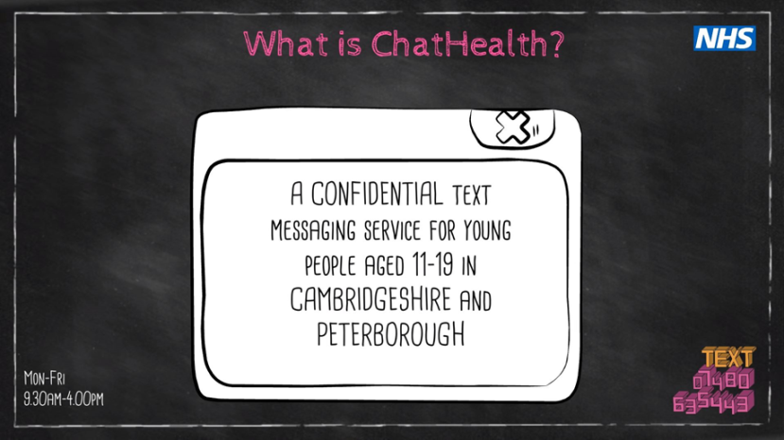
Please share this email to help us spread the word about ChatHealth!
https://vimeo.com/354621452 | Call us:  0300 029 50 50

*To put this in an email*
Click 4 arrowed icon at the top of the table right click, select “copy”.

Then create a new email and in the big message box simply select
“paste using source formatting” to insert the content.

#2 Website Information

ChatHealth Cambridgeshire and Peterborough

ChatHealth is a secure NHS approved text messaging service that is run by the NHS Cambridgeshire Healthy Child Programme.

From 9.30am to 4.00pm Monday to Friday ChatHealth has experienced clinicians online waiting to answer and deal with any messages from young people.

The new platform provides an alternative way for young people to engage with school nurses on topics including relationship advice, healthy eating, smoking cessation, bullying and exam stress.

All users need to do is text 07480 635 443 to start a conversation.

Over the next few months, there will be the distinctly branded ChatHealth credit cards, wristbands, posters around the school community to help advertise the service and there is even an animation to explain ChatHealth.

*INSERT ANIMATION HERE ON WEBPAGE*

Option 1 – use this code to embed the animation the webpage:

<<<iframe src="https://player.vimeo.com/video/354621452" width="640" height="360" frameborder="0" allow="autoplay; fullscreen" allowfullscreen></iframe>

Simply copy the code above and paste it into the HTML coding of the webpage

Option 2 – insert the animation picture (on the next page) and hyperlink it to this web address:

https://vimeo.com/user93371153/review/354621452/23319950d7

Option 3 – Insert this text “CLICK HERE TO WATCH THE ANIMATION” then highlight/select it and hyperlink it to the web address below:

https://vimeo.com/user93371153/review/354621452/23319950d7

If you would like to know more about ChatHealth or have any questions, please contact the the Cambridgeshire and Peterborough Healthy Child Programme on: 0300 029 50 50 or send an email to ccs.cpft.hcp@nhs.net.

A choice of Pictures
Simply select an image, right click the mouse and select “save as picture” to extract a picture from this document

- Animation Picture

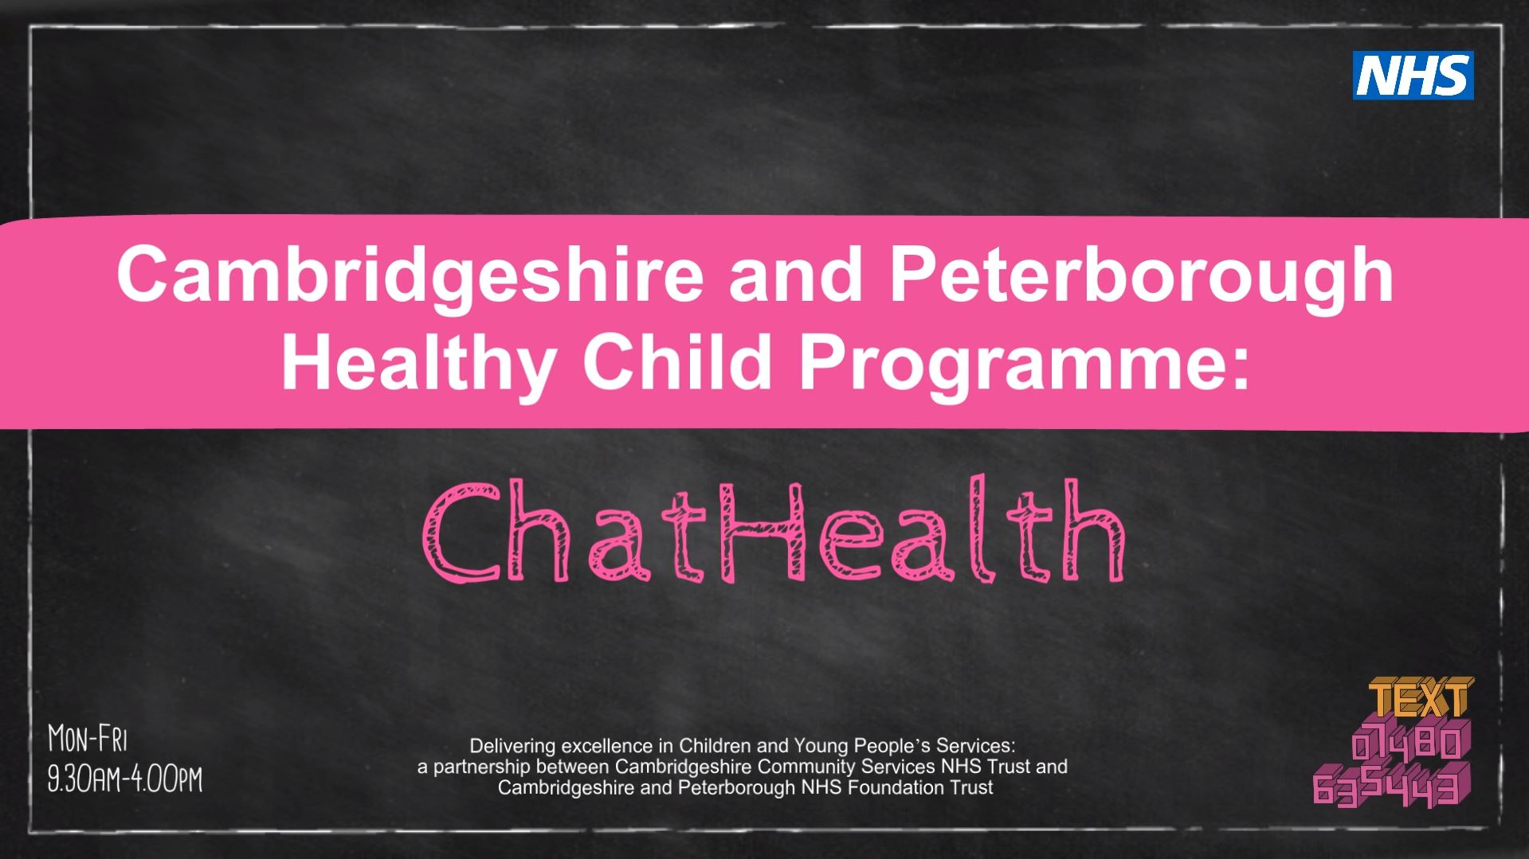

- Poster text 1

- Poster text 2

- Full Poster

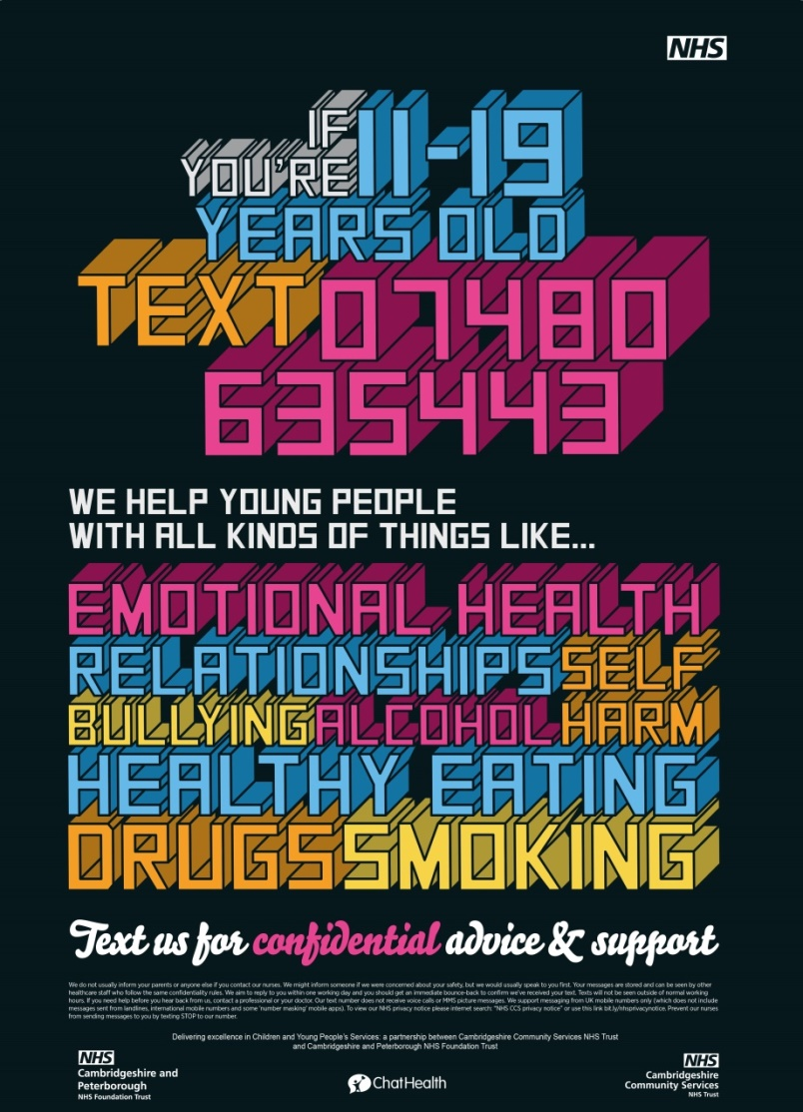

#3 Newsletter Articles

Article 1

ChatHealth Cambridgeshire and Peterborough
NHS launches text messaging support service to improve the lives of young people across Peterborough.

NHS has recently launched ChatHealth – a secure and confidential text messaging service for young people aged 11-19 across Peterborough who are struggling to cope with a wide range of health issues including sleeping, relationship problems, alcohol, drugs, healthy lifestyle and eating.
The confidential text messaging service opens a new line of communication to young people and gives them an excellent opportunity to anonymously get in touch with a healthcare professional for that much-needed support with a simple touch of a button.
ChatHealth has been very successful in Cambridgeshire in the past two years and including Peterborough is another positive step to integrate services to get better outcomes for young people in the region.
ChatHealth, which is run by the Cambridgeshire and Peterborough Healthy Child Programme, is available to people Monday to Friday between: 9.30am to 4.00pm. To access the service all users need to do is TEXT 07480 635 443 to start a conversation. Anyone who tries to reach out to ChatHealth for help out of hours will receive a bounce back message explaining where to get help if their question is urgent, and when they can expect a response. Texts are usually replied to within one working day and cost the same as a standard text or will come out of your contract message allowance.
Service Lead, Cambridgeshire and Peterborough Healthy Child Programme, Andrea Graves said: “ChatHealth is a great new line of communication for young people in Cambridgeshire and Peterborough which gives an alternative way to engage with school nurses and tackle the issues that are standing in their way of happiness.”
“Since the launch of this innovative support service, Cambridgeshire alone received a total of 6,326 text messages and in return sent 7,499 messages.”

To find out more about ChatHealth, watch the short animation here: https://vimeo.com/354621452/bc044f70ef

For further information or for promotional materials to advertise ChatHealth, please contact the Healthy Child Programme on:

0300 029 50 50

Article 2

ChatHealth opens a new line of communication to young people in Peterborough

NHS has recently launched ChatHealth – a secure and confidential text messaging service for young people aged 11-19 across Peterborough who are struggling to cope with a wide range of health issues including sleeping, relationship problems, alcohol, drugs, healthy lifestyle and eating.
The confidential text messaging service has been very successful in Cambridgeshire in the past two years and including Peterborough is another positive step to integrate services to get better outcomes for young people in the region.
ChatHealth is available to people Monday to Friday between: 9.30am to 4.00pm. To access the service all users need to do is TEXT 07480 635 443 to start a conversation.
Service Lead, Cambridgeshire and Peterborough Healthy Child Programme, Andrea Graves said: “ChatHealth is a great new line of communication for young people in Cambridgeshire and Peterborough which gives an alternative way to engage with school nurses and tackle the issues that are standing in their way of happiness.”

To find out more about ChatHealth, watch the short animation here: https://vimeo.com/354621452/bc044f70ef

For further information or for promotional materials to advertise ChatHealth, please contact the Healthy Child Programme on: 0300 029 50 50.

Article 3

Start a conversation with ChatHealth – a secure and confidential text messaging service for young people across Peterborough.

ChatHealth gives young adults an opportunity to anonymously get in touch with a healthcare professional for support on issues such as sleeping, relationship problems, alcohol, drugs, healthy lifestyle or healthy eating that are getting in the way of leading a good quality of life.
You can contact ChatHealth team by simply texting 07480 635 443 to start a conversation from Monday to Friday 9.30am - 4.00pm excluding bank holidays.
For further information, please contact the Healthy Child Programme on: 0300 029 50 50.

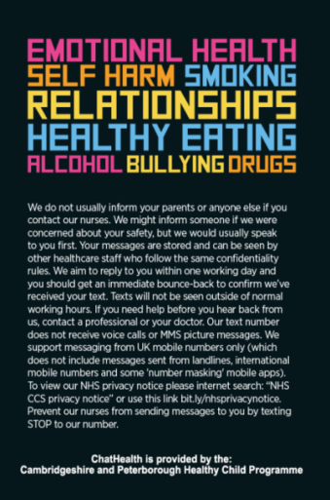

*Please feel to use any additional pictures used in the document*

#4 Resources

If you would like to know more about ChatHealth or have any questions, please contact the the Cambridgeshire and Peterborough Healthy Child Programme on: 0300 029 50 50 or send an email to ccs.cpft.hcp@nhs.net.

Alternatively you can visit our dedicated Chathealth page:
http://bit.ly/34xFSLF

