Sensory Strategies: Washing

Sensory Strategies
- Use unscented soap to decrease sensitivities.
- Use a heavy flannel and apply pressure strokes on the body.
- Try different flannels, sponges, loofah’s etc to see which your child prefers.
- If your child is fearful in balance-related activities, try showering rather than bathing (because there are less changes in body position).
- Water that is warm to the touch is the best temperature; have your child test to ensure comfort.
- Children who do not like water in their eyes or on their face may find wearing swimming goggles or a shampoo shield helpful.
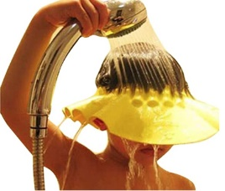

- Try to incorporate fascination with water falling from the tap and bubbles into play while washing.
- Dim the lights and minimise sound if your child is easily overwhelmed.
- Allow choice of shower or bath.
- When shampooing apply deep pressure to head.
- Use pressure when drying with a towel.

Other Strategies
- Tell your child when you plan to touch him or her with the flannel or bath brush or foam brush.
- Use cognitive preparation strategies; for example, “We will wash your right arm and then your left arm.”
- Use visual aids to assist with the comprehension of the task.
- Provide lots of water play in a sink or bowl with fun toys (eg squirt gun, boat, diver, squeeze bottle, bubbles, bubble bath, bath foam soap, soap crayons, roll-on soap).

