Sensory Motor Tools for the Classroom Sensory Breaks

Some children are easily over stimulated or distracted by sounds, others by touch or visual stimulation. Some children need movement of their hands, legs or mouth to focus their attention. All children need an appropriate environment and good seating.

Using some of the Sensory tools given below you can help to:
• alert
• organise
• focus and settle children within the school day by increasing their attention
• decreasing defensiveness and helping to modulate their levels of arousal.

Some children might need to take a regular sensory break, perhaps every 20 minutes, others at transition times and others first thing in the morning and afternoon.

Choose the activities the child enjoys and adapt as necessary.

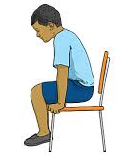
Chair Push Ups
- Sit in a chair with your feet flat on the floor.
- Put your hands to your sides with palms flat and fingers curled around the edge of the chair.
- Push up so that your bottom comes off the chair seat and feet come up off the floor.
- Use your arms and hands to help push you up and lower you down.
- Whatever your age do that many Chair Push-ups.

Trampette bounce
You can increase the difficulty level for the child as necessary.
- Do 10 - 20 jumps counting out loud.
- Do 10 Star jumps counting out loud.
- Jump and catch a ball or bean bag 10 to 20 times.

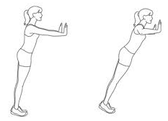
Wall press ups
- Lean against wall arms extended and hands flat.
- Bend your elbows as you lower your body towards the wall. Keep your feet still.
- Hold for a count of four and then slowly push yourself back.
- Repeat 10 times.

Rolling ball- do slowly
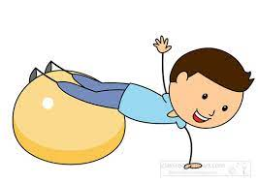
- With your tummy on the therapy ball walk hands out as far as possible without falling off and return to starting position.
- You may need support.
- When you feel confident, collect bean bags and throw into a bucket in front of you.

Bouncing ball
- Sit on the therapy ball with your feet on the floor.
- Bounce 10 times, keeping your feet on the floor.
- Bounce while throwing and catching.

The seat walk

- Sit on the floor with your legs and arms straight out in front of you.
- Lift up one side of your bottom by leaning to the side and push forwards.
- Shift and do the same thing on the other side.
- Keep on moving!
- You might find it easier at first to go backwards.
- Time how long it takes you to move across the room.

Tug of war
Play tug of war with ropes, scarves, stretchy bands.

The Plank
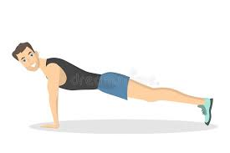
- Get onto all fours with your hands shoulder width apart.
- Take one leg behind you and push up onto your toes.
- Once balanced take the other leg behind you and do the same.
- Make sure your bottom is as flat as possible.
- Hold for a count of 4 and then get back onto your knees.
- Repeat 5 times.
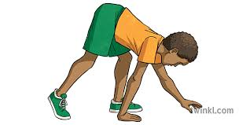
Bear walk
- Begin on the floor on your hands (flat) and feet.
- Keep your arms straight, elbows only slightly bent.
- Do a ‘bear walk’ with knees bent.

Blowing activities
- Blowing bubbles.
- Use straw and cotton balls or paper balls to play blow football.
- Whistles.
- Blow toys.

Hand Fidgets
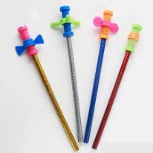
- Stretch toys such as Koosh balls and bendable rubber toys.
- Fidget pencil toppers.
- Beanie-like toy.
- Fiddle toys such as hair bands, key rings, bracelets.
- Therapy putty, silly putty or other ‘slime’ or ‘gloop’ to shape.

Sensitive Hearing
For children who are easily distracted and disturbed by unexpected noise, or even the usual classroom noises, earplugs, earphones and ear muffs can be useful.

Fidgeting
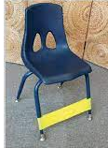
Very restless, fidgety children who cannot sit still can be helped by using the following:
- A ‘move and sit’ cushion. These help to give the child tactile and proprioceptive feedback as they move, and reduce the need for excessive fidgeting they also improve posture.
- Wrap ‘Theraband’ around the legs of the child’s chair to give them a resistive surface to kick against when sitting down.

Sensory Bags
While each child's "bag" should be based on his or her individual sensory needs, here are some suggestions that may help you get started.
- Fidget toys.
- Two footprints that can be put on the floor for jumping or stomping on.
- Lotion with one of the more calming scents, such as vanilla.
- Two handprints that can be placed on a wall as a deep pressure "push place".
- Natural smells.
- Mouthing toys such as blow toys, harmonica, chew toys, chews.
- Small toys with movable parts.
- Fabric swatches.
- A beanie baby type of tactile toy.

