Information for Teachers – Sensory Circuits
Participation in a short sensory motor circuit is a great way both to energise and settle children into the school day.
The aim is to focus concentration in readiness for the day’s learning. The circuit also encourages the development of the child’s sensory processing skills.
Many children can benefit from attending a Sensory Circuit, even for a short period of time. Record behaviours that you see in a child that suggests that they would benefit.

These include:
• Constant fidgeting in class
• Slow to start work and constantly missing cues
• Difficulty organising self
• Lethargic and dreamy
• Poor coordination and balance
• Known sensory processing difficulties
• Constantly rocking
• Has difficulty paying attention
• Lacking confidence to join in
Once you have selected the children you want to attend the circuit, the circuit co-ordinator and the class teacher need to set a target for each child.
This can be both a physical skills target and a sensory or behaviour target. For example; to improve balance and reduce calling out in class.
The circuit should be an active, physical and fun activity that children enjoy. Ideally is should be run first thing in the morning, and after lunch if at all possible.
The Sensory Circuit provides a sequence of activities done repeatedly to provide the child with the right type of sensory input in order to calm and organise them for the day ahead ready for learning to occur.
The idea is to start with something alerting, move to an organisation stage and then finally to a calming phase. The order is important; you don’t want a child to return to class wound up and hyperactive!

- Alerting
The aim of this section is to provide vestibular and proprioceptive stimulation within a controlled setting.
This prepares the brain for learning.
Activities can include such activities as:
• bouncing 10 times on a mini trampoline or space hopper
• spinning a hoop
• bunny hops / crab walks / frog
• Jumps
• therapy ball for rolling over and bouncing on,
• skipping
• walking on cans/stilts
- Squeezing stress balls, hand toys and play dough.
- Pressing hands/feet together or pushing with hands against the wall (arms straight).
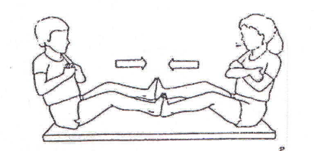
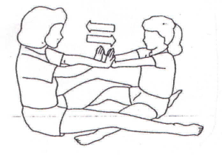

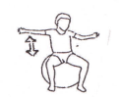

- Use small bubble-wrap pieces, pop the bubbles with thumb and fingers.
- Sitting on a therapy ball or space hopper and bouncing up and down or lying over the ball and rocking back and forth.
- Catching and throwing heavy weighted balls.
- Turtle Race: Place a large beanbag on your and the child’s back. Then crawl around circuit, slowest wins.

2. Organising
This section includes activities that require motor sensory processing, balance and timing. The child needs to organise their body, plan their approach and do more than one thing at a time in a sequential order.
Activities includes tasks such as:
• balancing on a beam
• log rolling
• climbing wall bars
• throwing bean bags into a target
• arm push ups against the wall
• blowing bubbles or blowing a paper ball to a target
• wobble boards for balance work
• T-stool for balance work (one legged stool).
• Skipping and jumping a moving rope
These are skills that may increase a child’s focus, attention span and performance within the classroom.
• Lifting books and toys back onto shelves.
• Lying on tummy on the floor to complete a fine motor task – this is a good anti-gravity position and gives heavy work to a lot of muscles!
- Wheelbarrow walks – The child walks on hands while adult supports hips or legs, do this in a controlled ay to protect and support hypermobile joints.
- Have the child close his/her eyes and ‘feel’ where his/her legs, hands, arms, etc. are. Ask if they are up or down. See if the child can get into different positions without looking, such as roll into a ball, touch his/her nose, make a circle with his/her arms, make an ’x’ with arms and legs, etc.
- Engaging the child in setting up activities and tidying up following activities.
- Use of a basic visual schedule or now and next chart to indicate what the child is expeceted to paticipate in during the day. Sensory breaks can be included on this schedule.
- Schedules can also be used to anticipate changes in routine, which can reduce anxiety.
- Social stories can also prepare Child for changes.
- Anticipating new environments including pictures of new places and people can be used on the schedule.

3. Calming
The calming activities are very important as they provide input to ensure that children leaves the circuit and return to their classrooms calm, centred and ready for the day ahead.
Activities include proprioceptive or deep pressure activities such as:
• placing feet or hands in weighted bean bags
• lying under weighted blankets
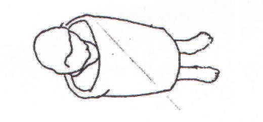
• having balls rolled over their backs
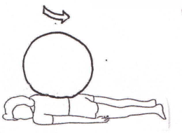
- A ‘hot dog’. The child lies down on a jumbo cushion or pillow (either on his/her front or back) and another cushion is placed on top (not on the face) and gentle firm pressure can be given by an adult in addition to the weight of the cushion (alternatively roll a ball/ space hopper on the child’s back).
- Being rolled up tightly in a blanket or P.E. mat. You can also roll a therapy ball up and down the child’s body during this activity.
- Slow deep breathing.
- Wearing a heavy coat and hat (when weather is appropriate).
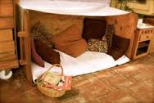
- A safe, calm and quiet space, such as a tent, den or separate room with lights and sensory toys which the child can use if overwhelmed.

Within the classroom setting it is often possible to transfer techniques used within the sensory circuits to continue to support a child. Frequent movement breaks can be built into the school day as necessary – ask your Occupational Therapist (OT) for more suggestions advice.
The Sensory Motor Circuits are based on the theories of sensory processing and sensory integration; please ask you OT for further information.
Equipment Recommendations
Sensory therapy ball  www.amazon.co.uk  www.sensorydirect.com | 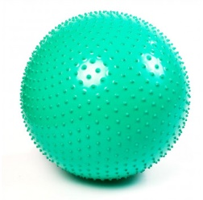
Therapy mat (Airex Coronella Mat – Blue)

www.completecareshop.co.uk
www.amazon.co.uk

Scooter board  www.sensorydirect.com  www.amazon.co.uk | 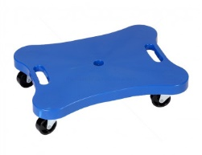
Sensory Tunnel

www.amazon.co.uk

Disco cushion  www.amazon.co.uk  www.sensorydirect.com | 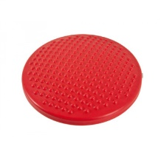
Wood massager

www.amazon.co.uk

Viperating snake

www.specialneedstoys.com
www.amazon.co.uk

