Resource list and ordering form
Name of document | Image | Quantity  (Please specify how many of each resource you would like)
Standards and guidance document | 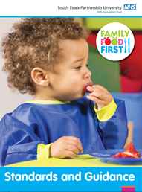
Healthy Celebrations pack | 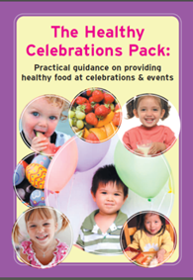
Healthy recipe flyer  Samosa Recipe Card  Or  Cheese Scone Recipe Card  Or  Tuna Fishcakes Recipe Card | 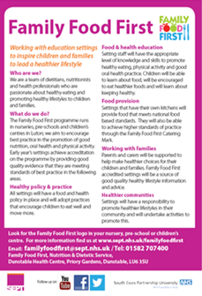
Healthy lunchbox leaflet (available in Polish – please specify) | 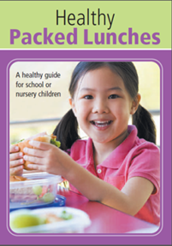
Children’s drinks – under 5’s guide to drinks  (available in Polish, please specify) | 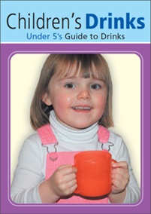
Healthy recipes for the family | 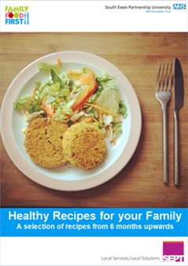

Name of setting: ___________________________________________________________________

Postal address:

Please send your order request to:
Family Food First
Nutrition and Dietetic Service
Bedfordshire Community Health Services
Dunstable Health Centre
Priory Gardens
Dunstable, LU6 3SU

